Alarm: Inserting Alarm
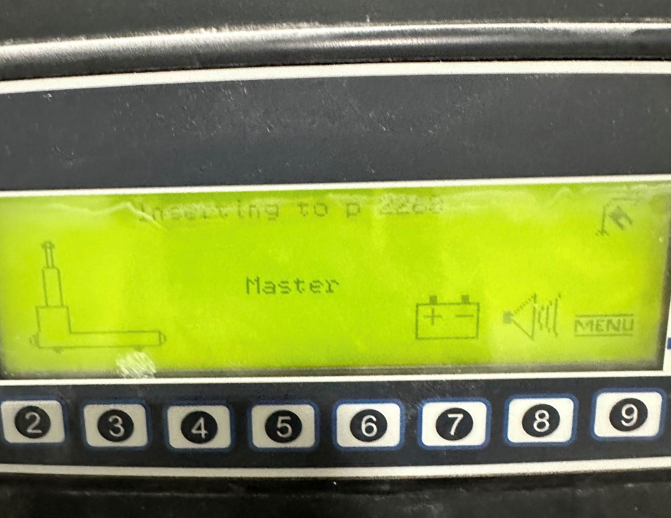
How To Fix:
This prompt appears when the AGV is attempting to insert into its drive path.
To manually insert the AGV:
- Ensure the AGV is oriented correctly and positioned at the center of the drive path.
To insert automatically using the remote:
- Set the AGV to Automatic Mode.
- Ensure the remote is in Forward Mode.
- Hold the speed stick towards the slow side.
The AGV will automatically drive and align itself into the drive path.

